**INTRODUCTION**

we have two major tools one is ORACLE 10G and the other is MS SERVER we to create Airline management on those servers so I picked oracle 10g and for (GUI) on form builder as we know we will make a front end for users to interact with the project. we use oracle 10g for the backend and frontend we will use form builder. So in the backend, we will use the oracle 10g database to perform data manipulation and data control by using SQL(Structure quire language ).

steps to define the process and the making of the project Here we have some functions of form builder we will define them with the introduction and we will define the according to the project and some attributes which are related to the project of the airline management system.

**Feedback on part 1**

**We simply gave the designation and on the base of the designation each pilot has the license their here flying eligible and each pilot flies a particular aero plane**

**So**

**When every we add a new data through UI user interface or through code , we make a relationship of staff to aero plane ,so when aero plane name changed then staff also change , that’s a point we find out each pilot assign particular aero plane and flying eligibility.**

**FORM BUILDER FUNCTION AND COMPONENT’S INTRODUCTION**

In this report we will call through each company one by one defining them and showing it just related to the company and to find them very well

* [**Blocks**](https://docs.oracle.com/database/apex-5.1/AEMIG/about-Oracl-forms-components.htm#GUID-328B72BC-C369-42D2-ADD4-9D1ABF7BFF31)

**In Oracle form builder blocks are created for interaction of user with the database blocks are useful to fetch data from the backend and show it to the user and we will put some functions in the block which will help user to interact with the data. User can perform tasks like manipulation of the data create update delete any function user want to perform user can perform using the interface**

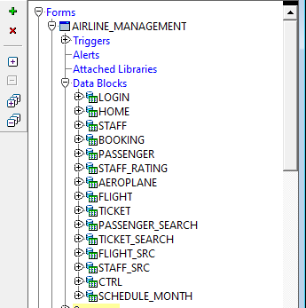

**In this image in our project we have created first the blogs of each and every table and after that we have created a home page which is useful for going and getting back to the tables and then we have a login page which is used for user to login or logout into our airline management system.**



**We have also created a control block which is used to control the functions and procedures of any other block is parent or child relationship in the attributes of the block . buttons are used in other block of other block**

* [**Canvases**](https://docs.oracle.com/database/apex-5.1/AEMIG/about-Oracl-forms-components.htm#GUID-2D37C51E-7E01-4FCD-BD4A-EF1D9D399231)

**Canvas are the objects that represent a background entity in which we can put items such as check boxes radio groups and text items there are four types of canvas contain, stake horizontal toolbar vertical toolbar**

**Content canvas is the basic type of canvas is which default type which is called pace it is a simple plane and Windows is displayed it as a simple page**

**The stack canvas is displayed in a stacked view like one canvas lies on another canvas they are often shown programmatically which are hidden**

**in the tab canvas, we show a large amount of information like a stack but we have buttons or tapes to navigate through the whole project**

**We have made our project on content canvas and we used the button to navigate through one canvas and two another**

[**List of Values**](https://docs.oracle.com/database/apex-5.1/AEMIG/about-Oracl-forms-components.htm#GUID-B1872849-F139-4515-B804-10DD84207003)

**In the form builder, we have a list of values like the list of passenger, flight, and staff ID then we will make a list if you want to search in different expect**

[**Program Units**](https://docs.oracle.com/database/apex-5.1/AEMIG/about-Oracl-forms-components.htm#GUID-9D4C6292-8778-4035-848A-8F4256589542)

**Program units are used in our project to build program unit build new functionalities which are not in our Oracle form builder such as login button search button and other buttons in which we use pl/SQL or SQL to see or two things such as we can create a master detail form which is which is joined on the SQL joins**

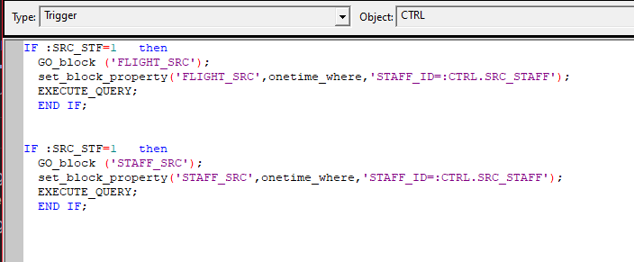

**Up in the image we have created a search button which is used to search between the flight and the staff like in both of them this is the functionality we have created using a program unit it is called a program unit in the airline management system**

* [**Property Classes**](https://docs.oracle.com/database/apex-5.1/AEMIG/about-Oracl-forms-components.htm#GUID-EC6E23AC-ECE2-4207-B208-0862E89464EB)

**We can find property palate in our Oracle form builder which is used to change the properties of a object or attribute like text or a whole block we can put some graphics using property plate and functions and we can create alert messages and we can perform a lot of functions using property palate**

**In the property plate we can use functions navigation and data and calculation we can perform calculation on data and we can see perform some functions on records and physical attribution as well the positions and official attributes as well visual attributes are used in our property plate to show some extra features which we have created we can change color also and it has font we can change font properties in the properties and it has a prompt which shows all the records at this plate**

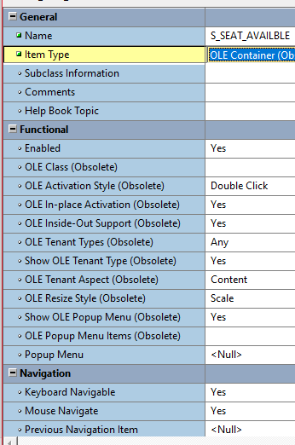

[**Record Groups**](https://docs.oracle.com/database/apex-5.1/AEMIG/about-Oracl-forms-components.htm#GUID-44927B29-26B8-4CAB-8E91-088092D5F0BD)

**Record groups is a data structure which is used in almost every block in the form builder to show to show records in the database.**

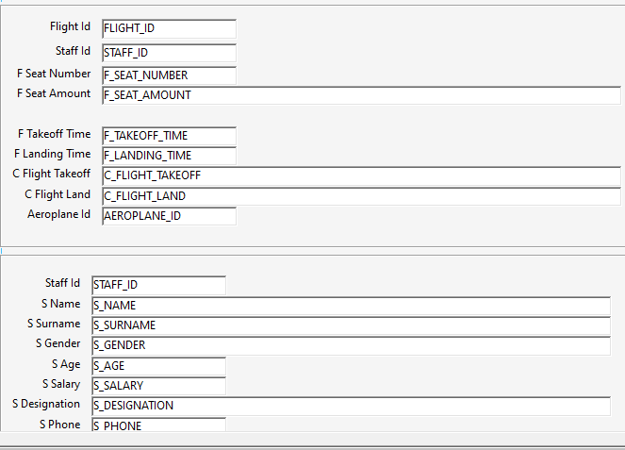

**Up in the table, we have shown the flight in the staff data columns which are the record groups in at structure which is a data structure in a form to show records**

[**Triggers**](https://docs.oracle.com/database/apex-5.1/AEMIG/about-Oracl-forms-components.htm#GUID-906CADCC-6C99-4A6E-A2BF-E5EF1F1EE16D)

**We can set triggers in the blogs on the patterns it is a PL SQL code which is written to perform any task specific with the event or specific with the user requirement like search button and create button**

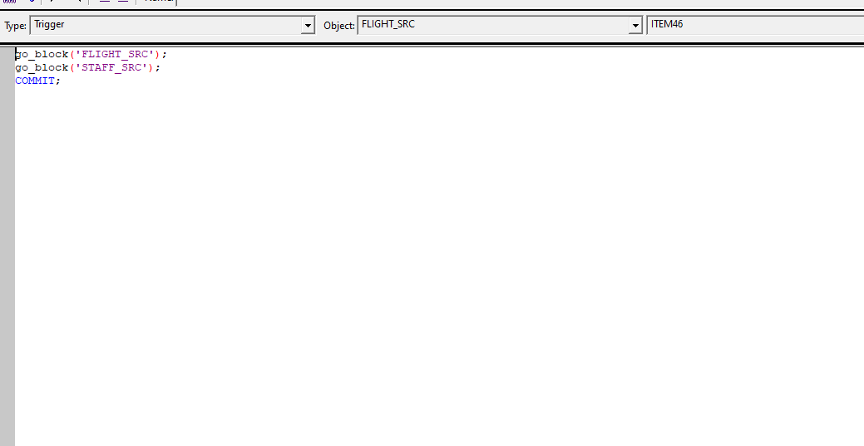

**Up in the picture we have shown the trigger of a button which is to save in that database**

[**Visual Attributes**](https://docs.oracle.com/database/apex-5.1/AEMIG/about-Oracl-forms-components.htm#GUID-03972729-5AF0-46F3-A943-51B3641660B1)

**Visual attributes are used in Oracle forms to define a collection of font color pattern at attribute that determine the appearance of any object and it is used on any object in the Oracle form builder**

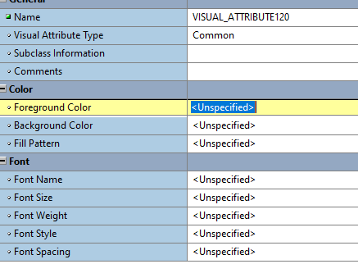

**Up in the picture, we have visual attributes the name it is used in any object to give color or font to the text of the object so we can use it anywhere in the form.**

[**Alerts**](https://docs.oracle.com/database/apex-5.1/AEMIG/about-Oracl-forms-components.htm#GUID-F7B6F7AD-FB52-4B58-9F72-BAE91C9E4E52)

**We can store an alert message in a text message in the Oracle application we can also use text messages to build a translatable text string with substitution variables which are called from pl/SQL procedure or functions or packages**

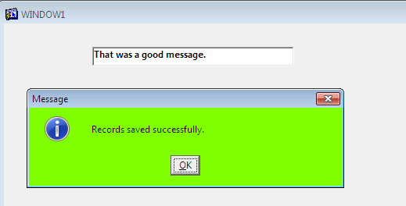

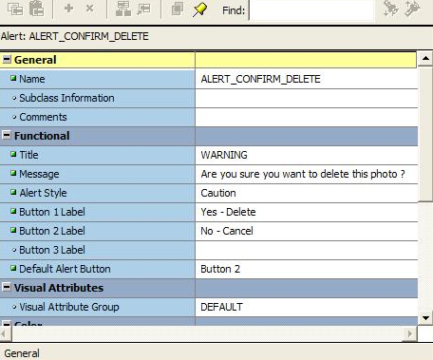

**Up in the picture we have shown that if someone want to delete a photo then alert message is can I show up and ask the user to delete it**

[**Windows**](https://docs.oracle.com/database/apex-5.1/AEMIG/about-Oracl-forms-components.htm#GUID-55646584-FFD3-4A91-B0A3-04ED7D023118)

**In the form builder, we have a container to contain all the visual objects and application including all the conversations all the pages of the project so the window is the interface window that is used in the application**

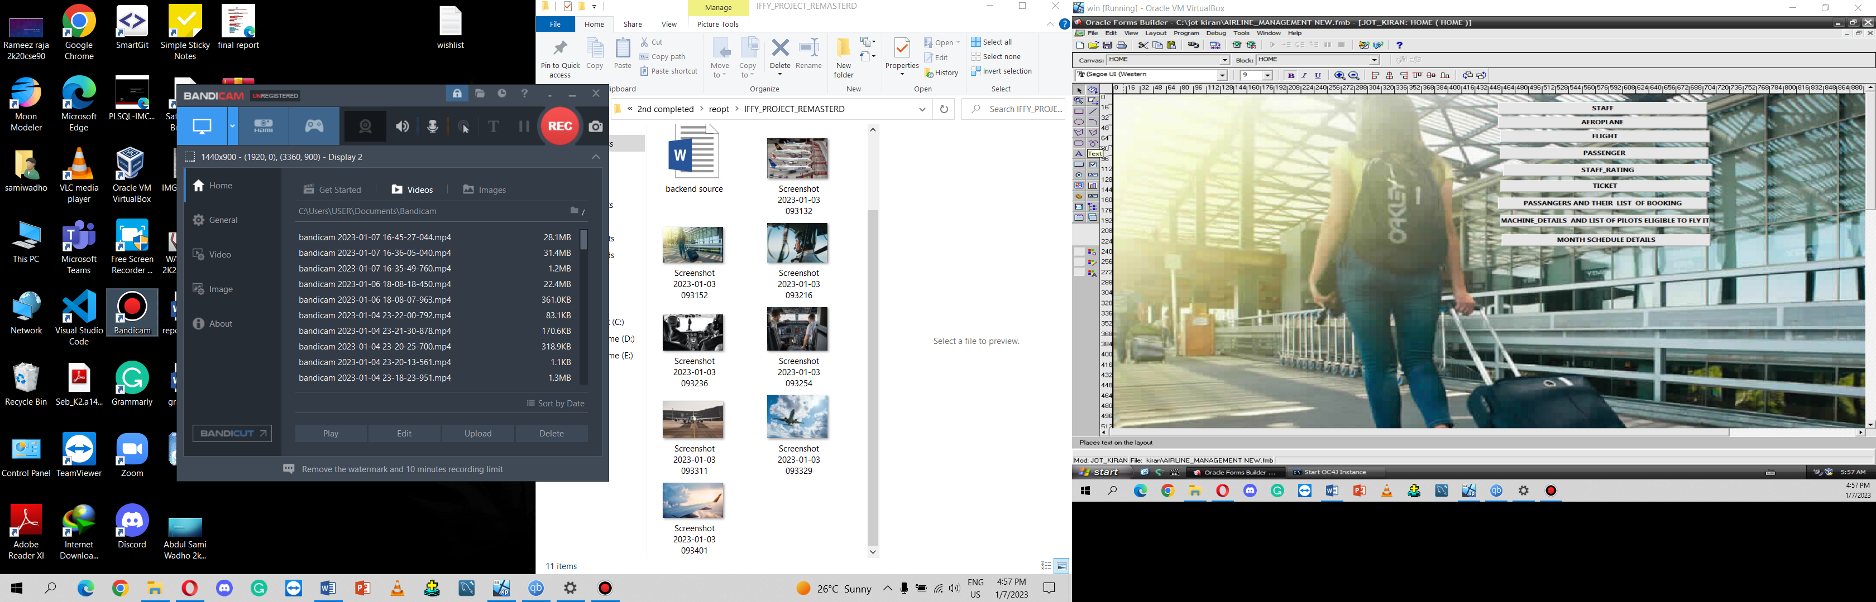

**Up in the picture we have shown the window of the airline management system home page and we can navigate through any object using only this window if we are going to go into any other module then it has another window**

FORMS MODULE TYPES

FORM MODULE

The form module is a simple module in which we create all the canvases and everything related to the airline management system

MENU MODEL

MENU MODEL is used to create menus in the form builder.

**Now we will start making the project in the form filter following the steps one by one and after completing all the steps we will get the airline management system**

**Steps in the project making of the airline management system**

**First, go to the desktop and press Windows+S to open search and type OC4j instance. you will open the instance and it is an instance used in the form builder to interact with the application we will run the application on Internet explorer so the instance will help us in running the application**

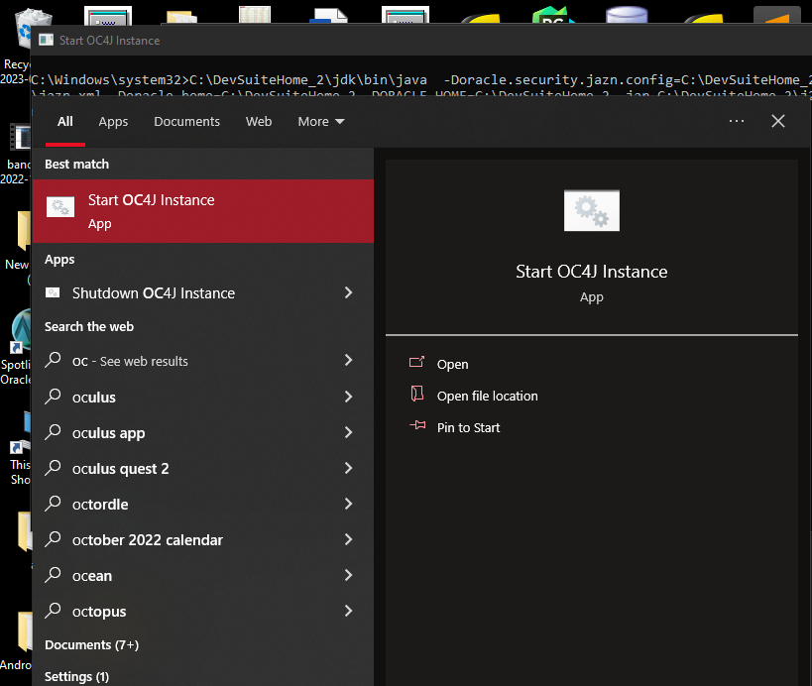

In the second step, we will open the form builder using same process which is used before to open the instance

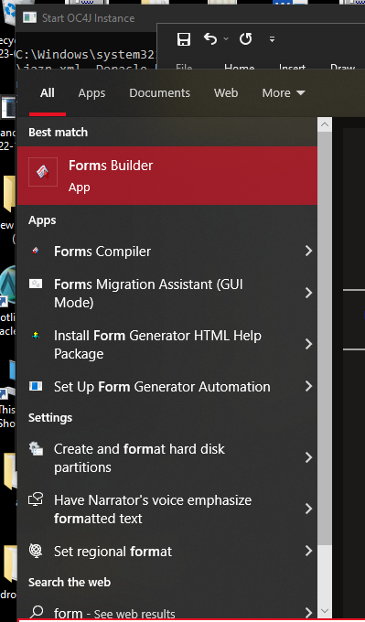

In the third step we are going create data blogs one by one of airline management system first we will

After running the form builder then we will follow the steps to create all the data blocks

FIRST STEP we will create an airline management system module using an object navigator

SECOND STEP we will create all the required data blocks and items using the database wizard

THIRD STEP we will apply the user interface using the object library

FORTH STEP which is uses layout wizard to design the layout of every block and in the

FIFTH STEP we will set object properties in the property palette

SIX STEP we will add all the code using SQL editor

rename the module and then we will create locks one by one block of each table is gonna be created and then we will create a master block.

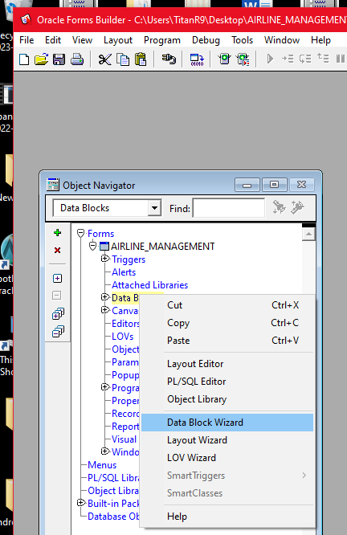

Up in the picture we have created the data blocks using data block wizard

In this picture we have created all the data blocks required in the airline management system then we will create a login page.

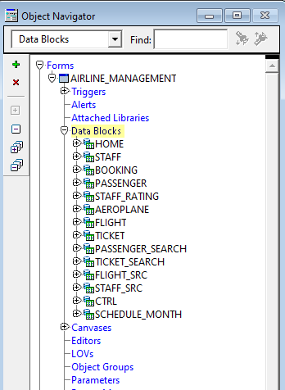//

After that we will create a master details form which is created by using two tables and joining them and representing them in one block

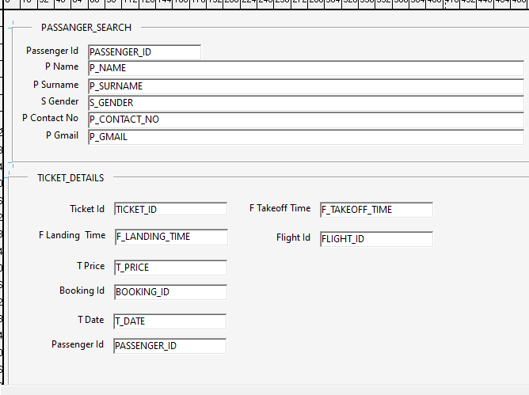

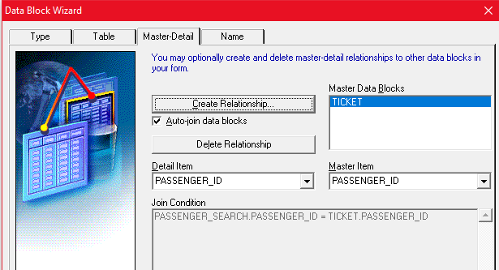

Up in the picture we have performed the join using the data block wizard

After creating all the blocks we will go to the homepage and create all the buttons to navigate through the blocks each button will take us to each block and also we will import some images for the GUI of airline management system those images are downloaded and converted and then imported in the form builder



After setting up all the property played properties of objects in each block and after that, we created all the blocks in the database including the login page

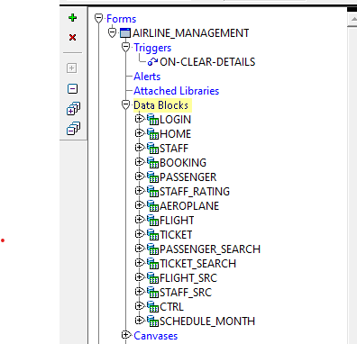

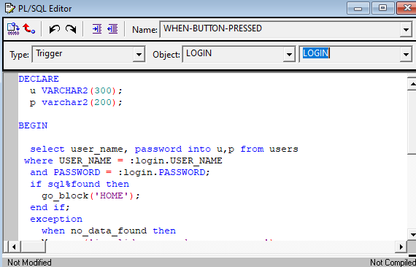

And then we will edit all the PL SQL and SQL code in the buttons of the database which were create update delete etc and we will also set back button and search button and all the related buttons with the form builder interface

We also have a login page in our airline management system which is used for user to login and logout of the system

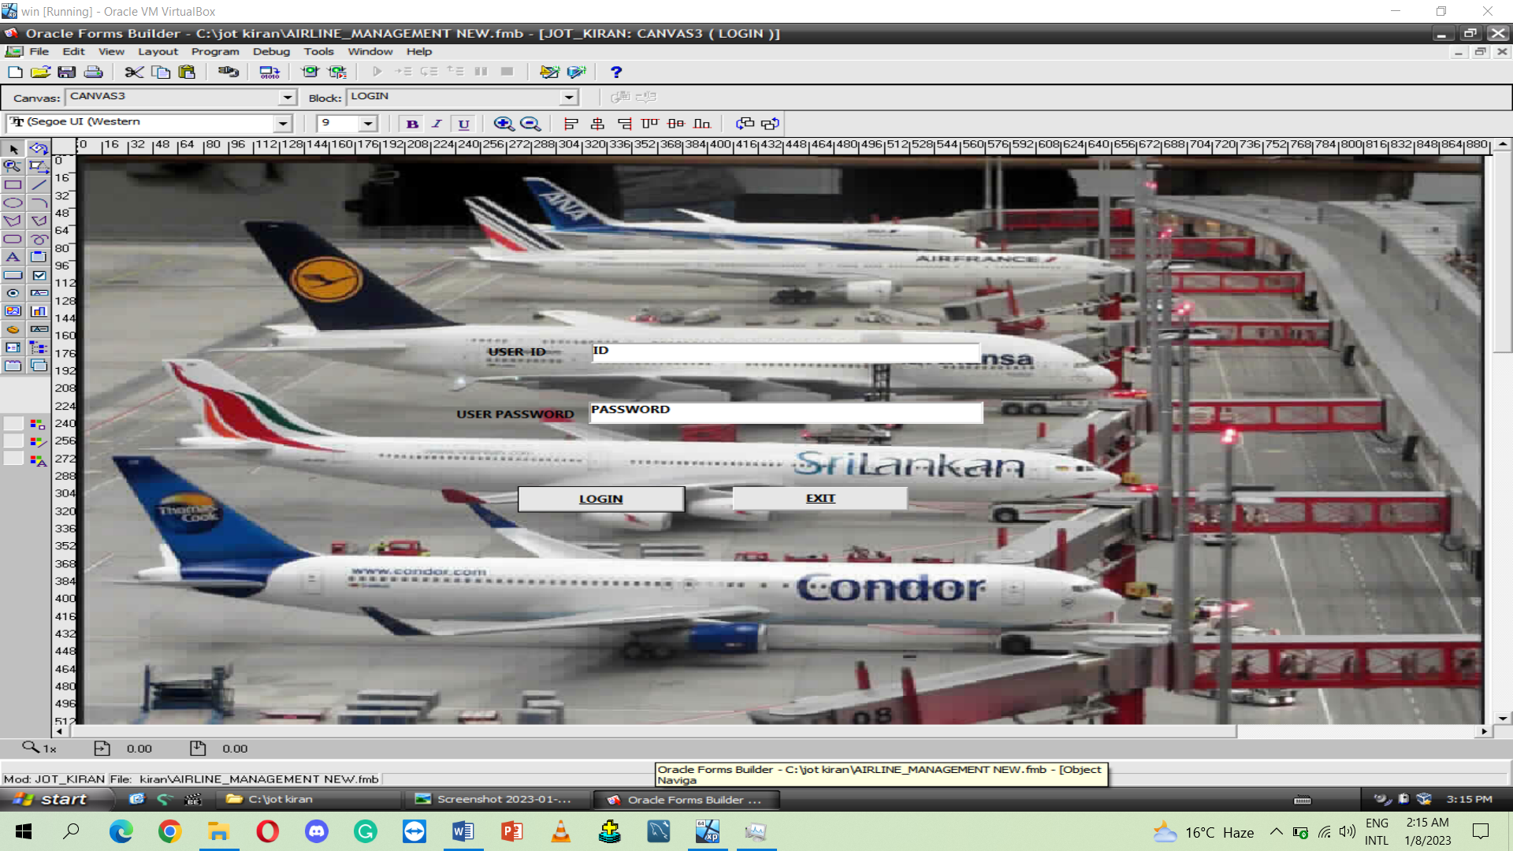

It is a form which is running in all the buttons are working correct everything works ok



When first we run the form we have to execute Curie and we have said that execute quick query in home button in each button of the block so when we click on the button it automatically excuse theory so we can see the data in the blocks so it's working well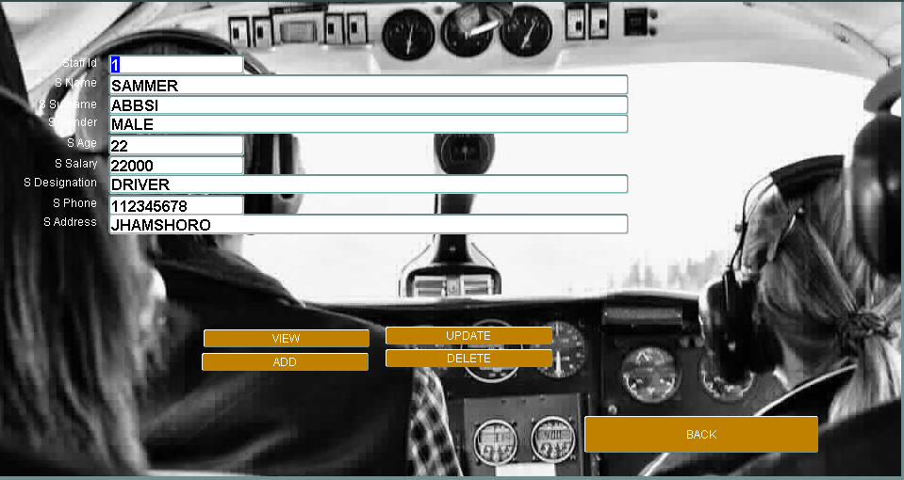

After that we will go to the block in which we have a search button then we will try to search something then we will find the record of search on ID so it works fine

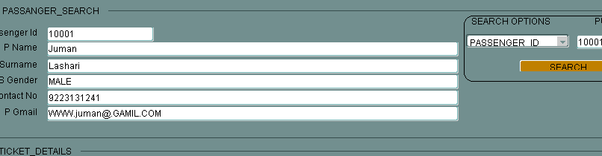

also created a search on a master detail form of flight and staff so when we search stuff ID it shows the data in both tables so it is working fine

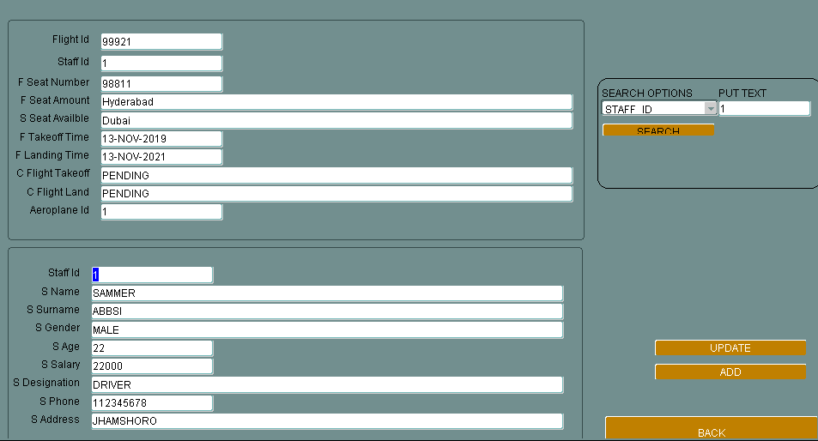

Overall conclusion

Through this project we have learnt how to create a complete airline management system how to put functionality in each and every block and use it and created for the user to interact with the database And also learn how to create a reliable airline management system for the user to interact.